Handout from [Award Winning Animation on Global Warming](http://www.youtube.com/watch?v=I9tCenQh3Rw&feature=related)

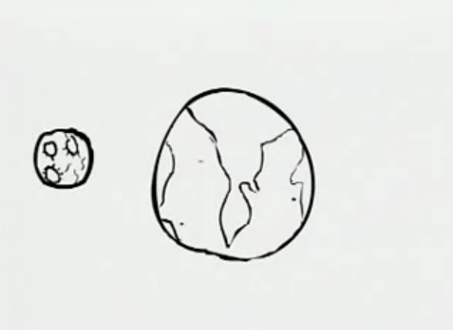

Caption:

____________________________________

____________________________________

____________________________________

____________________________________

____________________________________

________________________________________________

✂ ✂ ✂

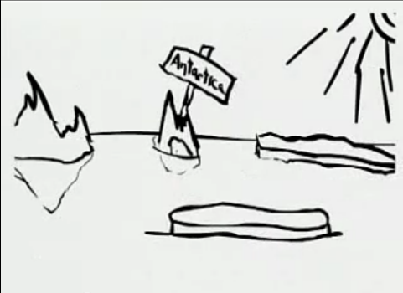

Caption:

____________________________________

____________________________________

____________________________________

____________________________________

____________________________________

________________________________________________

________________________________________________

✂ ✂ ✂

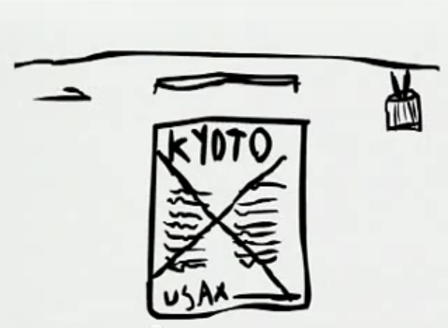

Caption:

____________________________________

____________________________________

____________________________________

____________________________________

____________________________________

________________________________________________

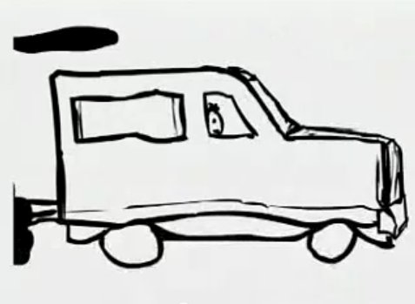

Caption:

____________________________________

____________________________________

____________________________________

____________________________________

____________________________________

________________________________________________

________________________________________________

✂ ✂ ✂

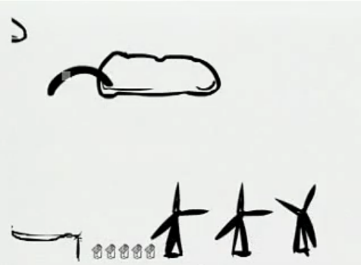

Caption:

____________________________________

____________________________________

____________________________________

____________________________________

____________________________________

________________________________________________

________________________________________________

✂ ✂ ✂

Caption:

____________________________________

____________________________________

____________________________________

____________________________________

____________________________________

________________________________________________

________________________________________________

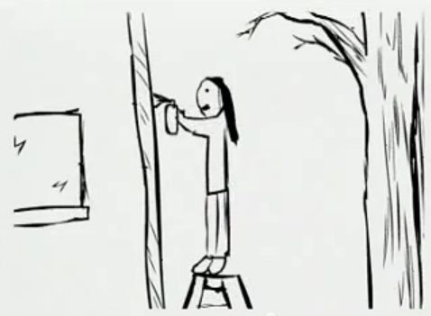

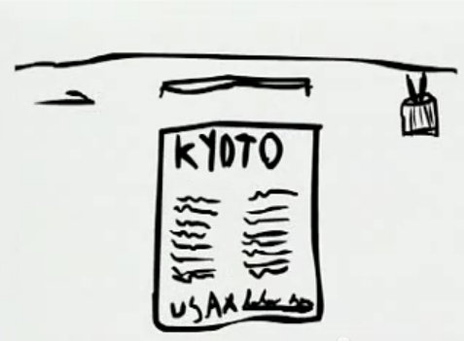

Caption:

____________________________________

____________________________________

____________________________________

____________________________________

____________________________________

✂ ✂ ✂

Rules:

* Must use complete sentences
* Must ____ [Teacher: Insert grammar point here] _________
* Must use vocabulary from the list
* Must flow together as a story
* Each person must write his or her own captions **-OR-** Must work as a group… remember your roles!
* Must finish in 10 minutes